**Team 1D345**

Abstract

The following images will show how the sky region is detected.

Image Conversion

Sky Region Detection

**Image Conversion Steps**

Initial Steps

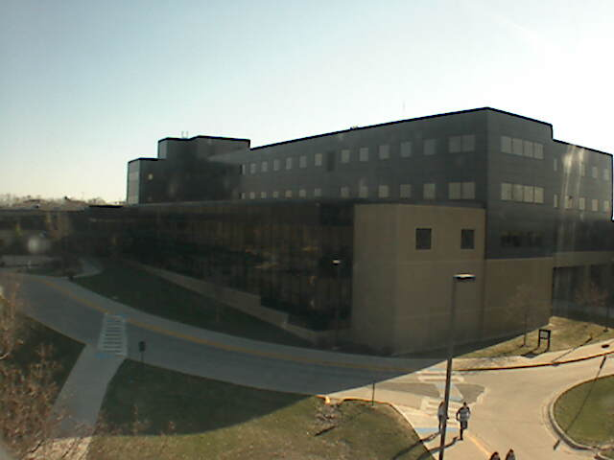

Input Image

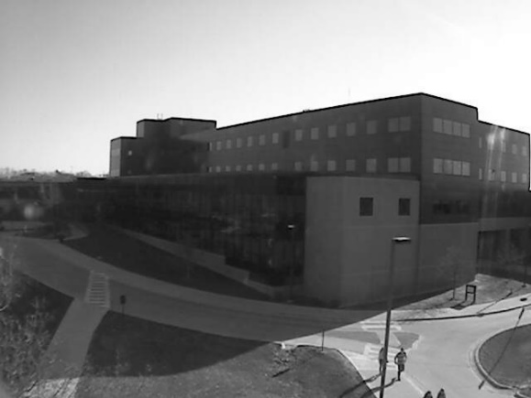

Greyscale Conversion

A grayscale (or grey level ) image is simply one in which the only colours are shades of grey. The reason for differentiating such images from any other sort of colour image is that less information needs to be provided for each pixel.

Helps in removing noise from the image

Image Masking

(Horizontal and vertical masking of pixels)

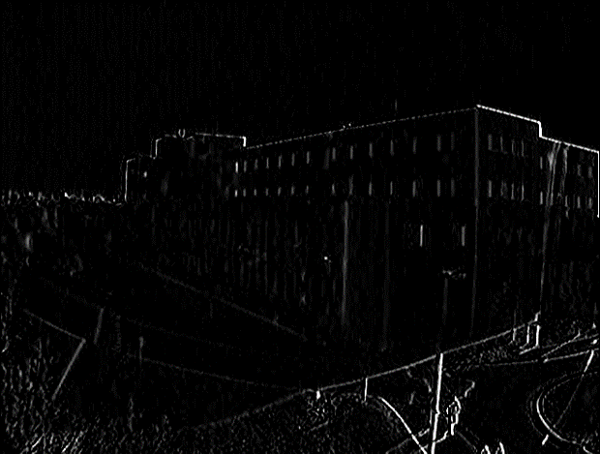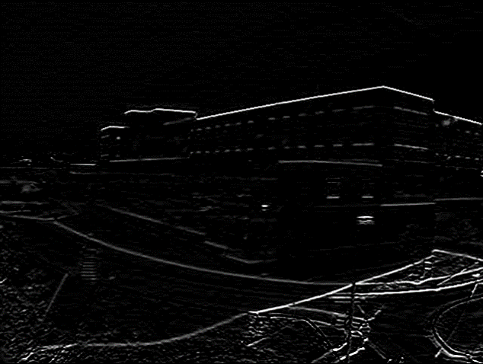

Superimposing masked Image

(to get final result)

The continuous black position is the sky with its separation 